 Blackboard 6 Student Manual

Special Education Department, George Mason University
Developed by Marci Kinas Jerome, Ph.D.

This manual will introduce you to the features of Blackboard and demonstrate step-by-step instructions on how to access specific components of your course online using Blackboard.

To Access Blackboard and Login to the Course

1. Enter the URL http://blackboard.gmu.edu into your browser location field. You will see the following screen appear:

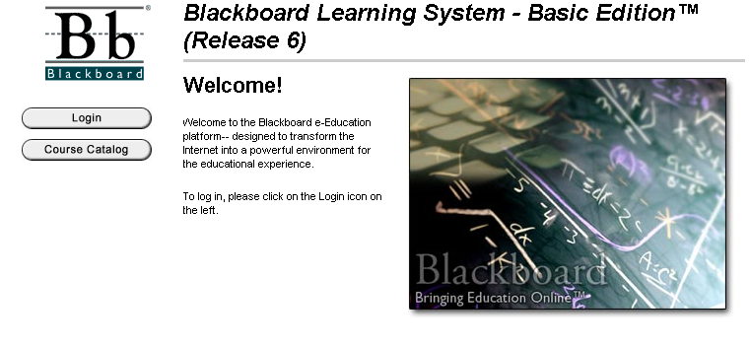

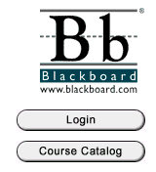
2. Click on the Login button.

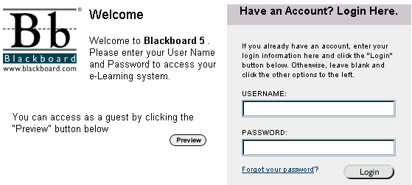
3. The Login button will take you to this next screen.

4. To Login: Enter the USERNAME ______________________ that has been assigned to you as both your USERNAME and PASSWORD in the blank spaces provided on the screen. (In most cases, your username and password are your first initial and last name; for example, jdoe for John Doe.)

5. Click the Login button and you will be directed to your Online Course Page. Notice that Blackboard is using your name in the Welcome area.

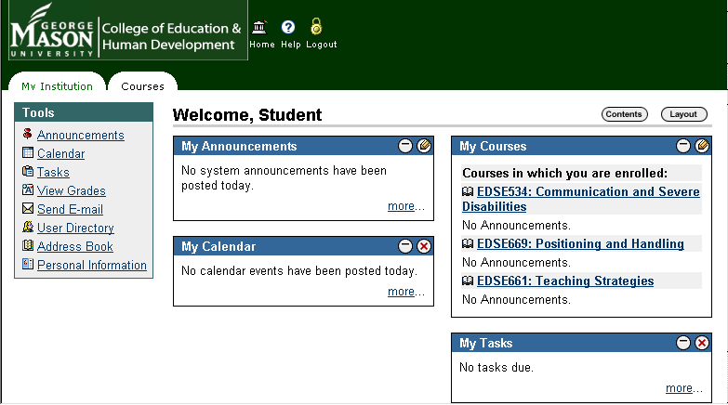

The CEHD Portal

When you first login to Blackboard, the CEHD Portal page appears. This page displays a composite list of information from any courses for which you are enrolled. The CEHD Portal page has four main components:

- The Navigation Buttons provide one-click access to the home page, the help page, and logout button.
- The Tools Area that provides easy access to certain course features.
- The Module Area displays the announcements, calendar items, and a variety of other information.
- The Navigation Tabs are used to navigate between segments of the software.

Tools Area: Personal Information

We recommend changing your password and verifying your email address on your initial login to the Blackboard course site.
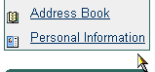
To Change Your Password
1. Click on the Personal Information link.

- Click on Change Password.

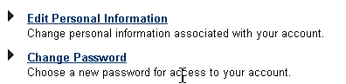

- Follow the directions. Type in a new password in the Password box, then type it in again in the Verify Password box. Click the submit button. Important: Write your password down in a safe place just in case you forget it.

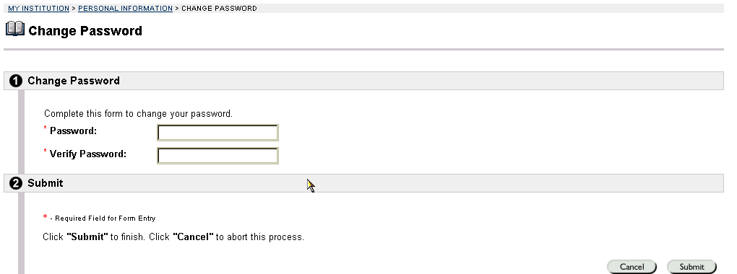

To Add Personal Information
- Follow the instructions for changing your password until you reach the Personal Information page.
- Click on Edit Personal Information

It is very important at this point to check your email address to make certain that it is correct. If your email address is not filled in, please fill it in immediately.

To Access your Course

- In the My Courses box you will see the course(s) in which you are enrolled such as Positioning and Handling. The name of the course is underlined on your screen to indicate that it is a hot link to the course itself. Click on Positioning and Handling.

- The Announcements feature will always appear on the first screen. You can view important messages from the instructors on the Announcements page. You can sort announcements by current date, last seven days, last thirty days, or view all course announcements by clicking on the tabs.

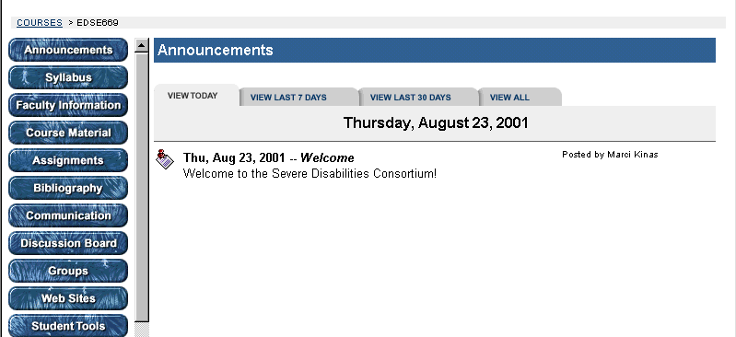

To Use the Course Navigation Buttons

Notice the Buttons (Course Information, Faculty Information, etc.) on the left side of the screen. You can access each of these areas by clicking on the button.

Course Information (or Syllabus)
- Click on the button and you will be linked to the Course Information page.
- This page contains the course Syllabus. In addition, a link has been provided to the MSWord Document so that it can be downloaded to your computer if you want to print a hard copy. To Download the Syllabus, click on Syllabus (Word Document).
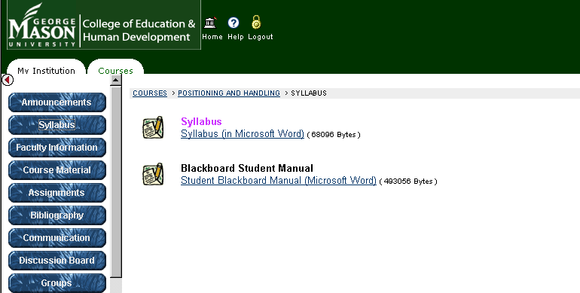

Submitting Assignments

Assignments list the name, description, and attachments for class work. Students complete the assignment in a separate file and send it back to the Instructor. They may also include comments for the Instructor if they choose. Assignment links may be found in several content areas such as “Assignments” and “Course Documents”.

To view and submit an assignment:
- Locate the assignment in the course content area. Note Assignments have a special icon and will say “view/complete assignment”
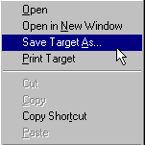
- To download the assignment to complete it, right click on the link for the “Assignment File”. Select “Save Target As” and save the file to your computer.
- To complete the assignment, open the saved file in the appropriate program on your computer, such as Microsoft Word. Add your responses to the document and save it. NOTE: You don’t have to stay in the “upload assignment” area to work on your assignment. You can download the file and return another day to upload the file and submit to the instructor.
- To submit your completed assignment, click on the “View/Complete Assignment” link (if it is not already open). In the comment area, add any comments you want the instructor to see. In the “Files to Attach” area click on the browse button and find the assignment that is saved on your computer. After you have attached your file, click the “submit” button. Once you submit your assignment you will get a confirmation screen that says, “The assignment has been successfully updated” with the date.

Using the Communications Tools

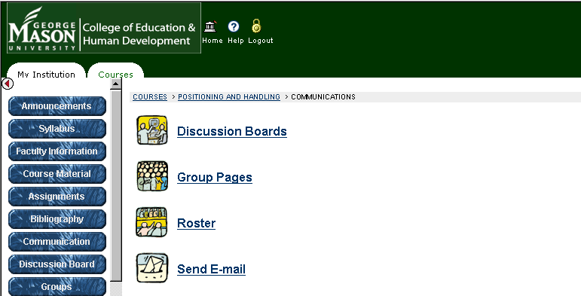

- Send E-mail
You can send email to anyone who is registered for this course, including the instructors without having to exit out of Blackboard.

- Discussion Board
The Discussion Board allows students to participate in asynchronous conversations within Blackboard.

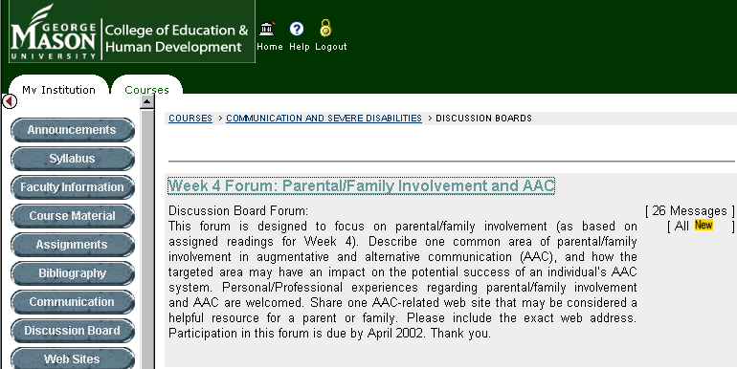

- Roster
The class list and email addresses of all participants are listed in this section. You may search by the name of the student or click on the List All tab. When you see a new screen, click on the List All button.
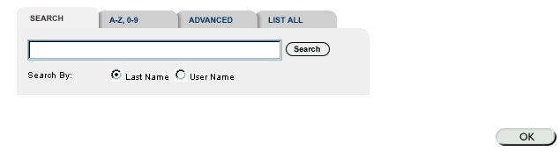

- Group Pages
Class participants may be divided into groups by university or by group project assignment.

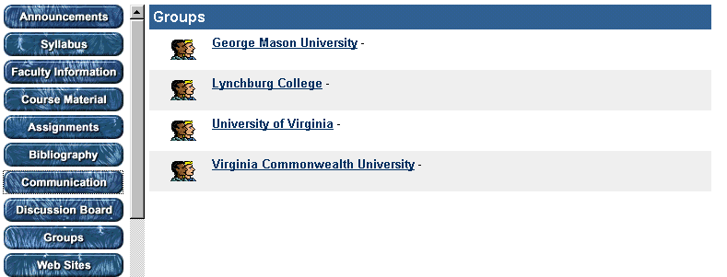

You have access only to your specific group. To enter your group page, click on your team name.

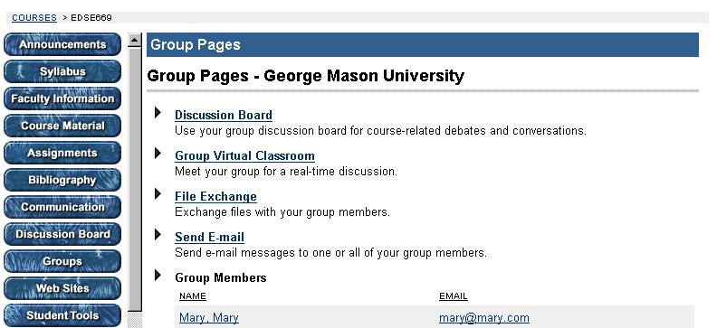

- Tools

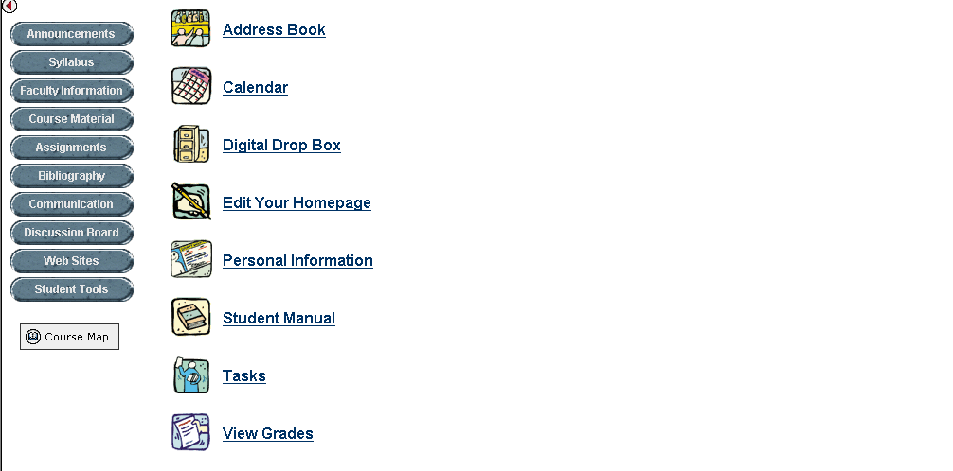

- Digital Drop Box
This feature allows students to submit work directly to the instructor. To access, click on the Digital Drop Box. You will see the following screen.

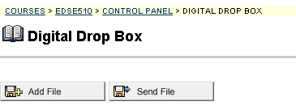

- Click on the Add File Button. The file information screen will ask for the file name and location.
- To find the file, click the Browse… button. The file name will appear in the box on the Blackboard screen.
- Highlight the file and click the Open button. The file name will appear in the box on the Blackboard screen.
- Click the Submit button.
- Once the file is listed on your Digital Drop Box screen, click the Send File button to transfer it electronically to the instructor.

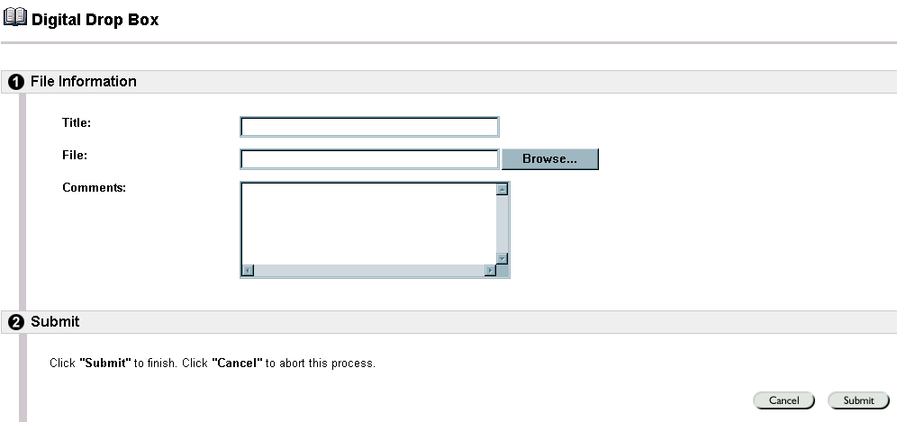

Editing Your Homepage

Every enrolled Student has a Course Homepage where they can post information about themselves. The Edit Your Homepage screen allows users to edit their Course homepages. The homepage is blank until the user edits the page. To view a Homepage for a user in the course go to the Roster, located in the Communication Center. When an individual is selected from the Roster their Homepage will appear.

To edit your homepage:
- Click Tools on the Course Menu.
- Click Edit Your Homepage.
- Add information to each of the fields and click the Submit button.
- If you want to upload a picture, check that both the file size and the image size are not too large. You may need to edit your picture for it display nicely on Blackboard.
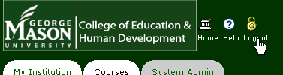
Logout Information

You should always logout of Blackboard by clicking on the Logout Icon at the top of your Blackboard screen.

